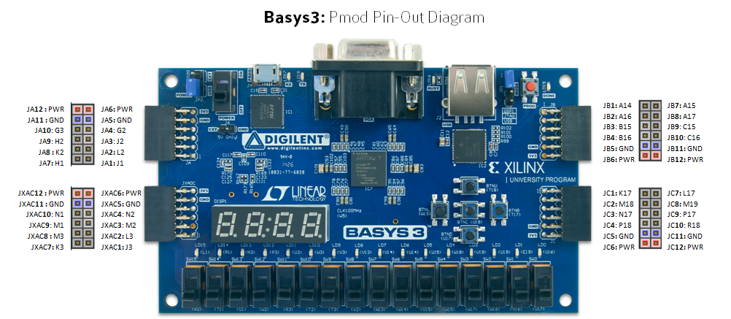

JA Top Row: SPI 0 (1 MB/s) JXADC Top Row: JB Top Row: JC Top Row:
SCK (4) Vaux 15p (4) Port 0 GPIO (1-4) Port 1 GPIO (1-4)
MISO (3) Vaux 14p (3)
MOSI (2) Vaux 7p (2)
SS(0) (1) Vaux 6p (1)
JA Bottom Row: SPI 1 (12.5 Mb/s) JXADC Bottom Row JB Bottom Row: JC Bottom Row:
SCK (10) Vaux 15n (10) PWM0 (7) SCL (7) I2C
MISO (9) Vaux 14n (9) Capture0 (8) SDA (8) I2C
MOSI (8) Vaux 7n (8) PWM1 (9) RXD (9) 9600 Baud UART
SS(0) (7) Vaux 6n (7) TXD (10) 9600 Baud UART

